Module 1 - Online Behaviour and Safety
Introduction and Link to Ontario Catholic Graduate Expectations
“I am a Learner for Life!”
Optional starting teacher-talk: As a part of the church community each of us are called to make a difference. One way we can do this is by being a Learner for Life. Over the next few days we are going to learn more about the computer and how the computer can help us learn, communicate, and make a difference in the world! Get ready to Cast Your Net!

Activity 1 - Minds On
Instruct students to stand up behind their desks with their chairs pushed in. Read out the list of statements below (How Well Do You Know Your Cyber Safety?). If the students believe the statement to be true, then they remain standing. If the students believe the statement is false, then they crouch down.
How Well Do You Know Your Cyber Safety?
1. The Internet can be compared to the telephone system.
True – the Internet is another way of communicating with people.
2. There are ways to make sure you are always safe and private on the Internet.
False – you are never completely safe or private on the Internet. A lot of people can access your information.
3. On the Internet, anyone could read my messages.
True – you can never be sure your messages will stay private – even in emails. A lot of different people, many of whom you do not know, could read your messages if the person you sent them to passes them on. Did you know that people can very easily push the “forward” button on a text message or email you send and then hundreds or thousands of people may see that message?
4. The Internet always gives you accurate information if you are doing research.
False – you have to ensure that the source you are receiving information from is reliable.
5. Sometimes people send messages to people they don’t really know because they have not had enough time to evaluate their level of friendship.
True – chat rooms and social networking sites like Facebook allow people to interact with people they don’t know very well – these types of interactions are not safe.
6. I should NEVER give out any personal information about me or my family to someone that I or my parents/guardians do not know or trust.
True – giving out personal information to someone you do not know or trust is dangerous and can lead to trouble. Protecting your digital identity is as important as protecting your regular identity.
7. Using my own name as a password is a good idea because I won’t forget it.
False – although it may be easy to remember, it is also easy for someone to guess and then hack into your computer and gain access to your personal information.
8. All sites are monitored and are therefore appropriate and safe for kids.
False – Child-friendly social networking (SN) sites provide safe opportunities for children to communicate with peers, explore different worlds and play games (e.g., Disney and Nickelodeon sites). Discussion boards on child-centered sites are usually monitored, block inappropriate language and allow users to post limited personal proﬁle information.
Adult SN sites, such as Facebook and MySpace, allow users to post more detailed personal information including pictures, discussion walls and personal proﬁles. Adult SN sites are meant for teens and adults only as the potential for child predators is much higher. This is why it is important to share with your parents the sites that you are on so that they may be able to help you determine if they are safe or not. If you think the site may not be safe, always check with a trusted adult.
9. I should never arrange to meet in person, someone I met online without my parents/guardian permission.
True – sometimes people you meet online are not who they appear to be. Sometimes bad people befriend you online so they can get you to meet them and then they hurt you. Never arrange a face-to-face meeting with someone you met online without telling your parent/guardian. If your parent/guardian agrees to the meeting make sure you meet in a public place with your parent/guardian present. It is potentially dangerous to meet unsupervised.
10. On the Internet, always treat everyone with respect.
True – this is called netiquette. Treating people with the same etiquette you would if you were talking to them face to face.

Activity 2 - Action
Use the Netiquette Word Web to support students in brainstorming what they know about netiquette and the risks associated with Internet use. Using the information from the web, create a class definition of netiquette. (Netiquette is a set of rules for everybody on how to behave properly online.)
At the end of the lesson the students will review and refine this definition.

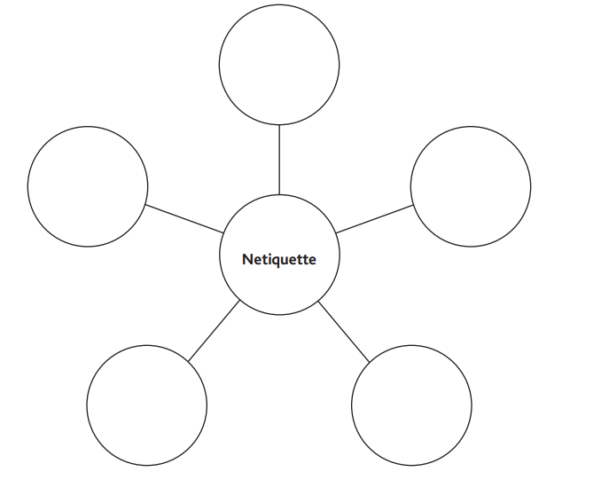

Before the video: Review with students what a newscast is and why the media uses newscasts as a way of communicating information. (A newscast is a broadcast of various news events and other information via television, radio or other media. Newscasts are visual and provide appeal and ease of disseminating information to a large audience.)
Watch and discuss the video, Being Safer and Smarter Online
Click here: http://www.reallifeonline.ca/Grade-4/Part-1--Netiquette.aspx

Activity 3 - Consolidate
First, ask the following questions as part of the consolidation:
What did we learn?
How can a computer be used to help others?
Next, review the definition of netiquette from the video. Working together, create an anchor chart that will outline ways the class will incorporate netiquette into their daily lives.
After refining the definition of netiquette, have the class think back to the video and what “rules” of netiquette were not followed. Students share with an elbow partner as many “rules” that they can think of that were broken.
Possible responses: Calling people names, Not being polite, Not respecting each other, Using capital letters when typing to signify “yelling” at someone).
Finally, discuss with the students why netiquette is important and how it relates to the Catholic Graduate Expectations, especially “I am A Learner for Life”.

