Module 3 - Cyberbullying
Introduction and Link to Ontario Catholic Graduate Expectations
“I have a voice!”
Optional starting teacher-talk: As a part of the church community each of us are called to make a difference. One way we can do this is by having a voice. Today we are going to learn how different types of communication can reach different audiences. The computer can help us achieve this goal and communicate in a way that respects everyone. The way we communicate face-to-face and the way we communicate online should be the same, where our caring words make other people happy.

Activity 1 – Minds On
Review the anchor charts from the previous modules. Review the definition of both netiquette and cyberbullying.
Watch Part 2 of Cyberbullying. Click here: http://www.reallifeonline.ca/Grade-6/Part-2--Impact-of-Cyberbullying.aspx

Activity 2 - Action
Gallery Walk Discussion Prompt: Organize the room into six stations with one discussion prompt at each station. Divide the students into small groups of 3-4. Using whole group direct instruction, inform the class that they will discuss the significant events that take place in the Connect[ED] video at each station and will record their responses on Student Worksheet - Gallery Walk. Have students confirm their understanding of the activity by using the Thumbs Up Strategy.

Student Worksheet – Gallery Walk

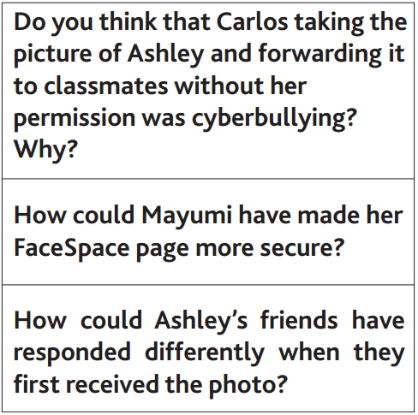
Discussion Prompts (from ConnectED OPHEA)

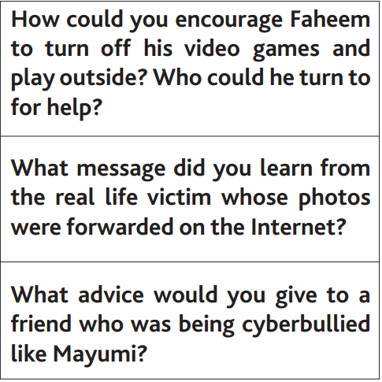

Activity 3 - Consolidate
Class Discussion/Anchor Charts: Can students ensure cyberbullying doesn’t take place online at school or at home? How will each student ensure they won’t be a “bystander?”
How can someone be an “effective communicator” in an online environment?
VIDEO: Find out what happened to the students from Rose Vine Elementary School by watching the “consequences” in part 3 here: http://www.reallifeonline.ca/Grade-6/Part-3--Consequences.aspx

